附件1 企业信息调查表格

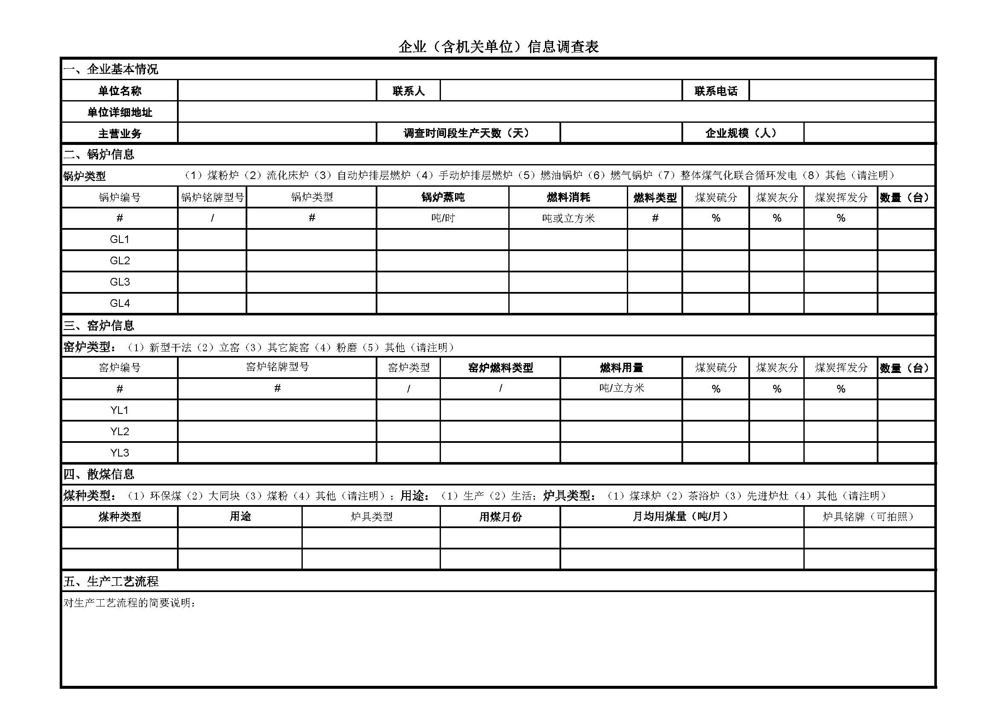

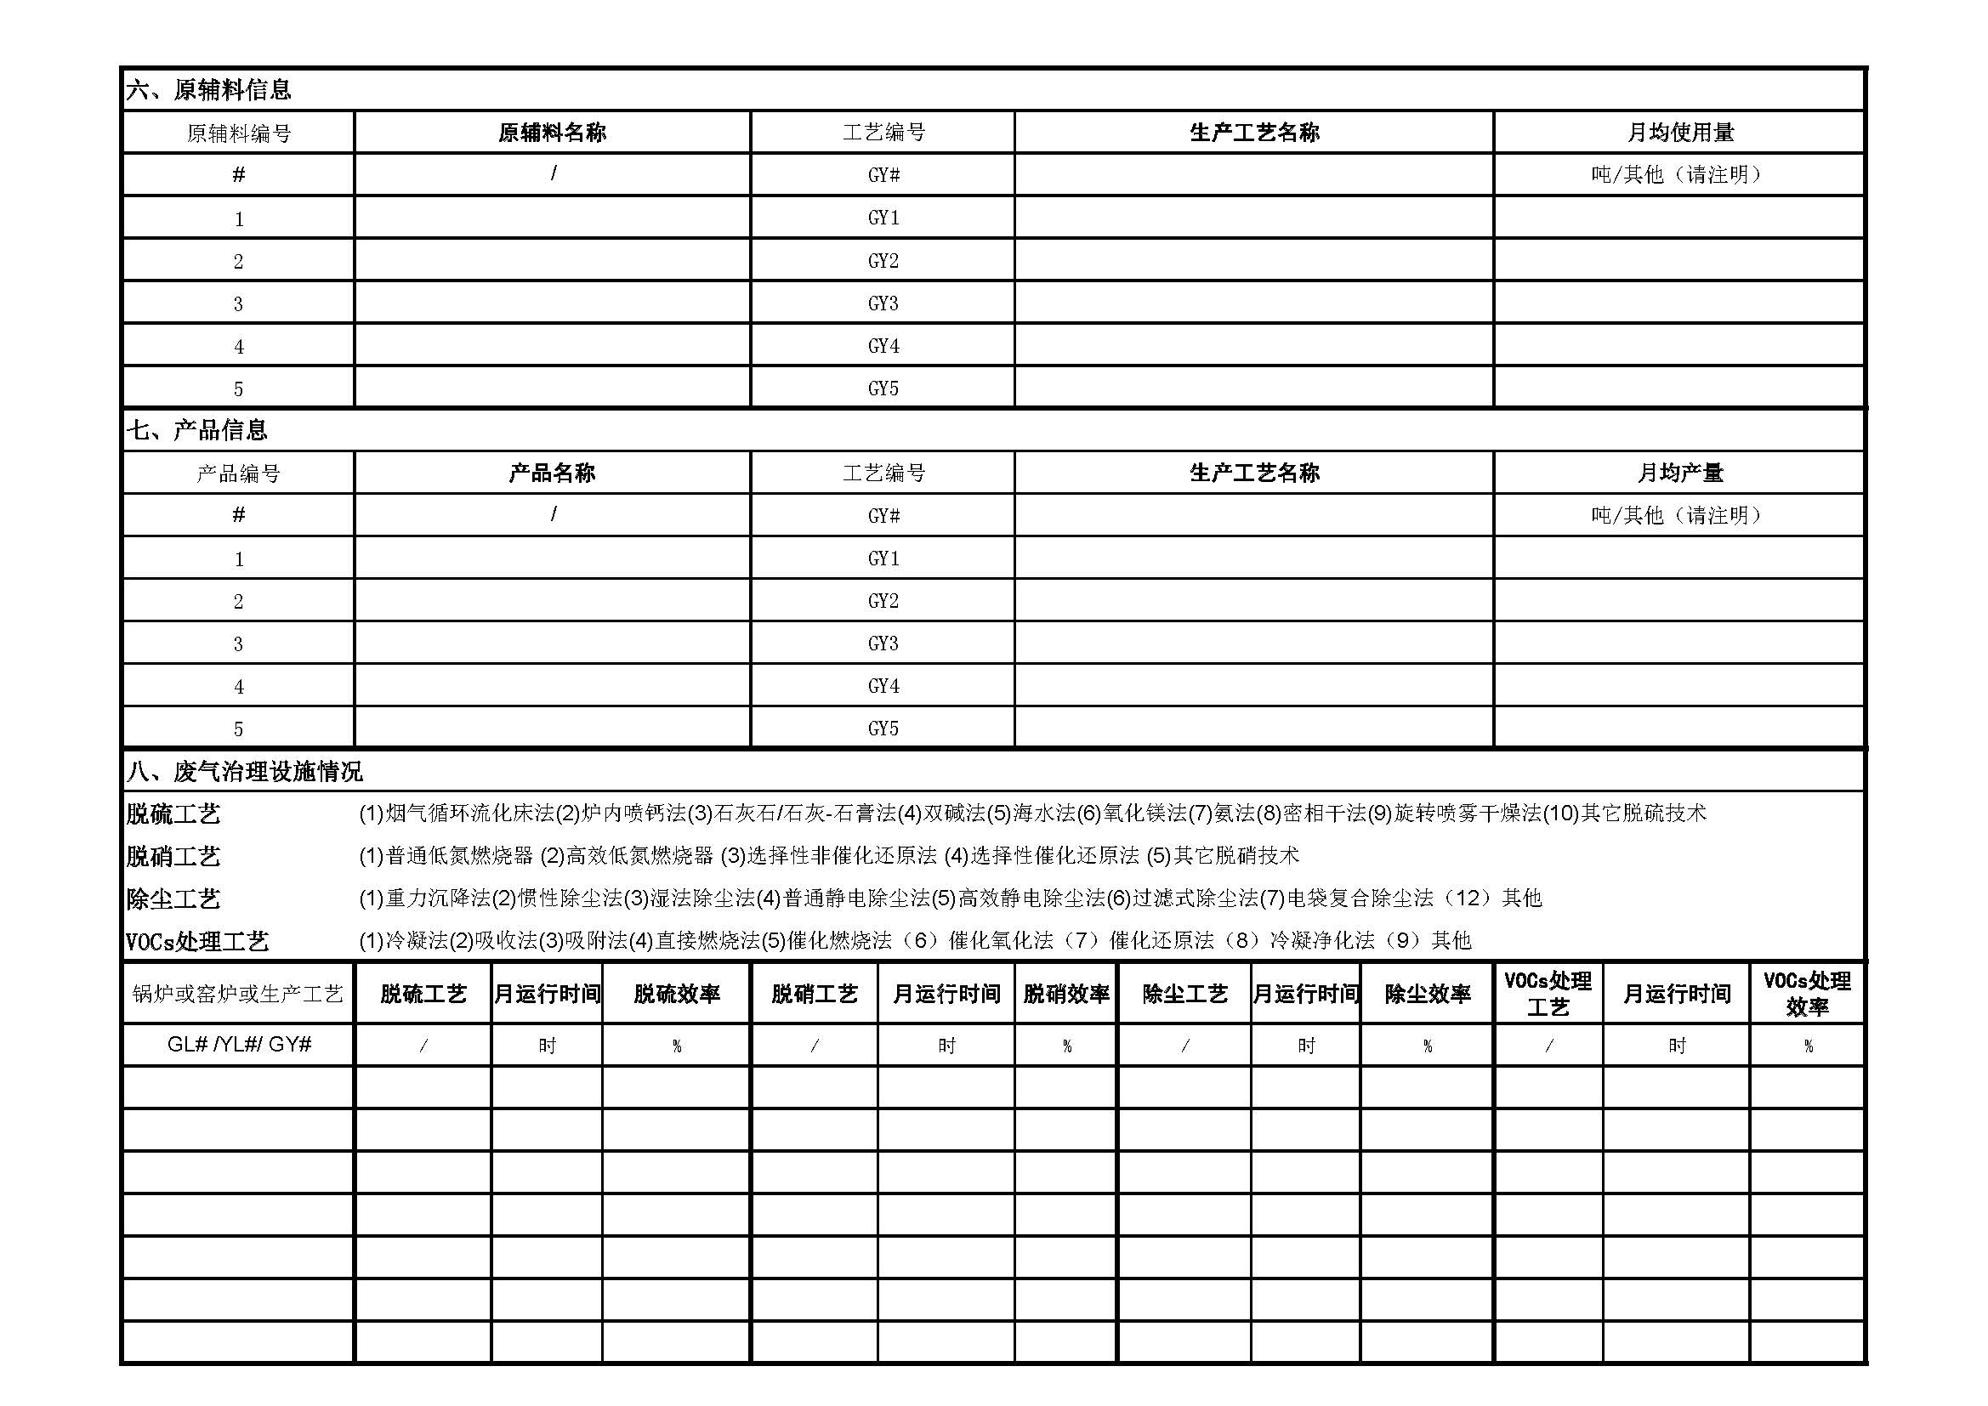

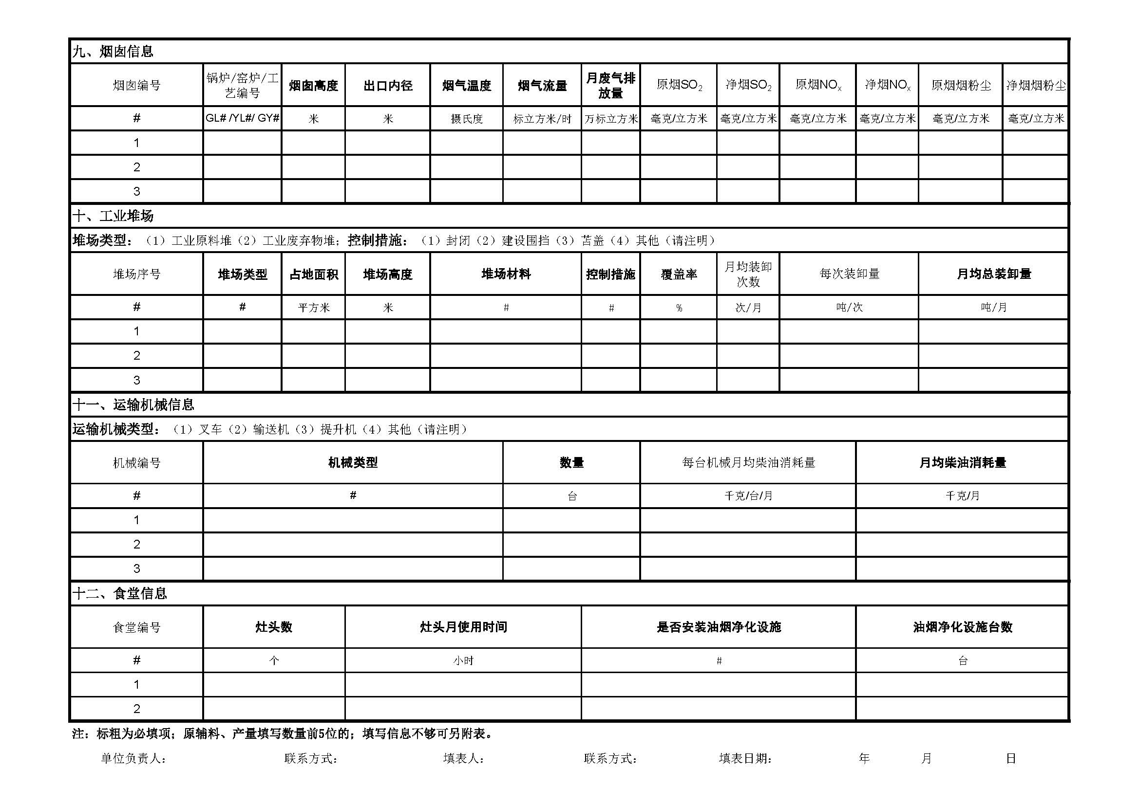

附件2

工地信息调查表格

|  |  |  |  |  |  |  |  |  |  |  |
| --- | --- | --- | --- | --- | --- | --- | --- | --- | --- | --- |
| **工地名称** | **工地类型**（建筑工地、拆迁工地、地铁建设、其他工地） | **详细地址** | **活动区域占地面积（平方米）** | **施工开始时间** | **施工结束时间** | **施工阶段**（土方开挖/地基建设/主体建设/装修与配套设施） | **控尘措施** | **施工机械种类**（（1）挖掘机（2）推土机（3）装载机（4）叉车（5）压路机（6）摊铺机（7）平地机（8）其他） | **施工机械总数量（辆）** | **施工机械月均总耗油量（吨/月）** |
|  |  |  |  |  |  |  |  |  |  |  |
|  |  |  |  |  |  |  |  |  |  |  |
|  |  |  |  |  |  |  |  |  |  |  |
|  |  |  |  |  |  |  |  |  |  |  |
|  |  |  |  |  |  |  |  |  |  |  |
|  |  |  |  |  |  |  |  |  |  |  |
|  |  |  |  |  |  |  |  |  |  |  |
|  |  |  |  |  |  |  |  |  |  |  |
|  |  |  |  |  |  |  |  |  |  |  |
|  |  |  |  |  |  |  |  |  |  |  |
|  |  |  |  |  |  |  |  |  |  |  |
|  |  |  |  |  |  |  |  |  |  |  |

附件3

道路交通信息调查表格

|  |  |  |  |  |  |  |  |  |  |  |  |  |
| --- | --- | --- | --- | --- | --- | --- | --- | --- | --- | --- | --- | --- |
| 道路序号 | **道路名称** | **是否铺装** | **平均车流量(辆/天）** | | | | | | | | | |
| **出租车** | **小型客车** | **公交车** | **中型客车** | **大型客车** | **小型货车** | **中型货车** | **大型货车** | **三轮车** | **摩托车** |
| 1 |  |  |  |  |  |  |  |  |  |  |  |  |
| 2 |  |  |  |  |  |  |  |  |  |  |  |  |
| 3 |  |  |  |  |  |  |  |  |  |  |  |  |
| 4 |  |  |  |  |  |  |  |  |  |  |  |  |
| 5 |  |  |  |  |  |  |  |  |  |  |  |  |
| 6 |  |  |  |  |  |  |  |  |  |  |  |  |
| 7 |  |  |  |  |  |  |  |  |  |  |  |  |
| 8 |  |  |  |  |  |  |  |  |  |  |  |  |
| 9 |  |  |  |  |  |  |  |  |  |  |  |  |
| 10 |  |  |  |  |  |  |  |  |  |  |  |  |
| 11 |  |  |  |  |  |  |  |  |  |  |  |  |
| 12 |  |  |  |  |  |  |  |  |  |  |  |  |
| 13 |  |  |  |  |  |  |  |  |  |  |  |  |
| 14 |  |  |  |  |  |  |  |  |  |  |  |  |

附件4

道路保洁信息调查表格

|  |  |  |  |  |  |
| --- | --- | --- | --- | --- | --- |
| 道路序号 | **道路名称** | **是否铺装** | **每天清扫次数（次/天）** | **清扫方式（湿扫/干扫)** | **每天洒水次数（次/天）** |
|
| 1 |  |  |  |  |  |
| 2 |  |  |  |  |  |
| 3 |  |  |  |  |  |
| 4 |  |  |  |  |  |
| 5 |  |  |  |  |  |
| 6 |  |  |  |  |  |
| 7 |  |  |  |  |  |
| 8 |  |  |  |  |  |
| 9 |  |  |  |  |  |
| 10 |  |  |  |  |  |

附件5

喷涂汽修店信息调查表格

|  |  |  |  |  |  |  |
| --- | --- | --- | --- | --- | --- | --- |
| **店铺名称** | **店铺地址** | **溶剂使用类型** | **溶剂使用量** | **是否有处理装置** | **处理装置型号** | **处理装置效率** |
| # | / | （1）普通漆（2）金属漆（3）珠光漆 | 千克/月（其他请说明） | # | # | % |
|  |  |  |  |  |  |  |
|  |  |  |  |  |  |  |
|  |  |  |  |  |  |  |
|  |  |  |  |  |  |  |
|  |  |  |  |  |  |  |
|  |  |  |  |  |  |  |
|  |  |  |  |  |  |  |
|  |  |  |  |  |  |  |
|  |  |  |  |  |  |  |
|  |  |  |  |  |  |  |
|  |  |  |  |  |  |  |
|  |  |  |  |  |  |  |
|  |  |  |  |  |  |  |
|  |  |  |  |  |  |  |
|  |  |  |  |  |  |  |
|  |  |  |  |  |  |  |

附件6

干洗店信息调查表格

|  |  |  |  |  |
| --- | --- | --- | --- | --- |
| **干洗店名称** | **干洗店详细地址** | **干洗机类型** | **干洗剂类型** | **干洗剂月均消耗量** |
| # | # | （1）开启式（2）全封闭式 | （1）三氯乙烯（2）四氯乙烯（3）其他（请注明） | 千克/月或其他（请注明） |
|  |  |  |  |  |
|  |  |  |  |  |
|  |  |  |  |  |
|  |  |  |  |  |
|  |  |  |  |  |
|  |  |  |  |  |
|  |  |  |  |  |
|  |  |  |  |  |
|  |  |  |  |  |
|  |  |  |  |  |
| **注：每项均为必填项，如没有请填“无”** | |  |  |  |
| 填表单位： 填表时间： 年 月 日 填表人： 联系方式： 审核人： | | | | |

附件7

加油站信息调查表格

|  |  |  |  |  |  |
| --- | --- | --- | --- | --- | --- |
| 序号 | **加油站名称** | **加油站地址** | **汽油月均销售量（吨）** | **柴油月均销售量（吨）** | **油气回收措施\*** |
| 1 |  |  |  |  |  |
| 2 |  |  |  |  |  |
| 3 |  |  |  |  |  |
| 4 |  |  |  |  |  |
| 5 |  |  |  |  |  |
| 6 |  |  |  |  |  |
| 7 |  |  |  |  |  |
| 8 |  |  |  |  |  |
| 9 |  |  |  |  |  |
| 10 |  |  |  |  |  |
| *注：加油站气回收系统主要分三个阶段的油气回收：  一次回收系统（即卸油油气回收系统）为将油罐汽车卸油时产生的油气，通过密闭方式收集进入油罐汽车罐内的系统；  二次回收系统（即加油油气回收系统）是将给汽车油箱加汽油时产生的油气，通过密闭方式收集进入埋地油罐的系统；  三次回收系统（即油气排放处理装置）是针对加油油气回收系统部分排放的油气，通过吸附、吸收、冷凝、膜分离等方法对这部分排放的油气进行回收处理的装置。 | | | | | |
|
|

附件8

城镇居民信息调查表格

|  |  |  |  |  |  |  |  |  |
| --- | --- | --- | --- | --- | --- | --- | --- | --- |
| **小区名称** | **所属街镇** | **户籍户数** | **户籍人口** | **取暖用煤户数** | **每户取暖平均用煤量** | **炊事用煤户数** | **每户炊事平均用煤量** | **环保煤比例** |
| # | # | 户 | 人 | 户 | 吨/年/户 | 户 | 吨/年/户 | % |
|  |  |  |  |  |  |  |  |  |
|  |  |  |  |  |  |  |  |  |
|  |  |  |  |  |  |  |  |  |
|  |  |  |  |  |  |  |  |  |
|  |  |  |  |  |  |  |  |  |
|  |  |  |  |  |  |  |  |  |
|  |  |  |  |  |  |  |  |  |
|  |  |  |  |  |  |  |  |  |
|  |  |  |  |  |  |  |  |  |
| **注：每项均为必填项，如没有请填“无”** | | |  |  |  |  |  |  |
| 填表单位： 填表时间： 年 月 日 填表人： 联系方式： 审核人： | | | | | | | | |

附件9

农村信息调查表格

|  |  |  |  |  |  |  |  |  |  |  |  |  |  |  |  |  |
| --- | --- | --- | --- | --- | --- | --- | --- | --- | --- | --- | --- | --- | --- | --- | --- | --- |
| **村庄名称** | **所属街镇** | **户籍户数** | **户籍人口** | **每户取暖用煤量** | **炊事用煤户数** | **每户炊事用煤量** | **每户炊事生物质焚烧量** | **农田面积** | **每亩氮肥施用量** | **露天秸秆焚烧面积** | **散养畜禽种类1** | **种类1养殖量** | **散养畜禽种类2** | **种类2养殖量** | **散养畜禽种类3** | **种类3养殖量** |
| # | # | 户 | 人 | 吨/年/户 | 户 | 吨/年/户 | 千克/天/户 | 亩 | kg/亩/年 | 亩/年 | # | 头(羽）/年 | # | 头(羽）/年 | # | 头(羽）/年 |
|  |  |  |  |  |  |  |  |  |  |  |  |  |  |  |  |  |
|  |  |  |  |  |  |  |  |  |  |  |  |  |  |  |  |  |
|  |  |  |  |  |  |  |  |  |  |  |  |  |  |  |  |  |
|  |  |  |  |  |  |  |  |  |  |  |  |  |  |  |  |  |
|  |  |  |  |  |  |  |  |  |  |  |  |  |  |  |  |  |
|  |  |  |  |  |  |  |  |  |  |  |  |  |  |  |  |  |
|  |  |  |  |  |  |  |  |  |  |  |  |  |  |  |  |  |
|  |  |  |  |  |  |  |  |  |  |  |  |  |  |  |  |  |
|  |  |  |  |  |  |  |  |  |  |  |  |  |  |  |  |  |
| **注：每项均为必填项，如没有请填“无”** | | | | |  |  |  |  |  |  |  |  |  |  |  |  |
| 填表单位： 填表时间： 年 月 日 填表人： 联系方式： 审核人： | | | | | | | | | | | | | | | |  |

附件10

餐饮信息调查表格

|  |  |  |  |  |  |  |  |
| --- | --- | --- | --- | --- | --- | --- | --- |
| **餐饮名称** | **详细地址** | **类型（快餐、中餐、火锅、烧烤、西餐、其他）** | **大小灶头总数（个）** | **是否安装净化设施** | **散煤使用月份（无、全年或月份）** | **散煤用途（取暖或生产）** | **散煤月均用量（吨/月）** |
|  |  |  |  |  |  |  |  |
|  |  |  |  |  |  |  |  |
|  |  |  |  |  |  |  |  |
|  |  |  |  |  |  |  |  |
|  |  |  |  |  |  |  |  |
|  |  |  |  |  |  |  |  |
|  |  |  |  |  |  |  |  |
|  |  |  |  |  |  |  |  |
|  |  |  |  |  |  |  |  |
|  |  |  |  |  |  |  |  |
|  |  |  |  |  |  |  |  |
|  |  |  |  |  |  |  |  |
|  |  |  |  |  |  |  |  |
|  |  |  |  |  |  |  |  |
|  |  |  |  |  |  |  |  |
|  |  |  |  |  |  |  |  |
|  |  |  |  |  |  |  |  |

附件11

裸地信息调查表格

|  |  |  |  |  |
| --- | --- | --- | --- | --- |
| 裸地具体地址 | 裸地类型（（1）未硬化或未绿化空地（2）草地（3）林地（4）农田（5）滩涂（6）干涸河谷（7）水域（8）裸露山体（9）其他） | 裸地面积（平方米） | 控尘措施（（1）植草覆盖（2）防尘网苫盖（3）防尘布苫盖（4）建设围挡（5）封闭（6）其他） | 覆盖率（%） |
|  |  |  |  |  |
|  |  |  |  |  |
|  |  |  |  |  |
|  |  |  |  |  |
|  |  |  |  |  |
|  |  |  |  |  |
|  |  |  |  |  |
|  |  |  |  |  |
|  |  |  |  |  |
|  |  |  |  |  |
|  |  |  |  |  |
|  |  |  |  |  |
|  |  |  |  |  |
|  |  |  |  |  |
|  |  |  |  |  |
|  |  |  |  |  |

附件12

堆场信息调查表格

|  |  |  |  |  |  |  |  |  |  |  |
| --- | --- | --- | --- | --- | --- | --- | --- | --- | --- | --- |
| **堆场类型：**（1）建筑原料堆（2）建筑废弃物堆（3）生活垃圾堆（4）工业堆料；**控制措施：**（1）封闭（2）建设围挡（3）苫盖（4）其他（请注明） | | | | | | | | | | |
| **堆场名称** | **详细地址** | **堆场类型** | **占地面积** | **堆场高度** | **堆场材料** | | **控制措施** | **覆盖率** | **月均总装卸量** | |
| # | # | # | 平方米 | 米 | # | | # | % | 吨/月 | |
|  |  |  |  |  |  |  |  |  |  |  |
|  |  |  |  |  |  |  |  |  |  |  |
|  |  |  |  |  |  |  |  |  |  |  |
|  |  |  |  |  |  |  |  |  |  |  |
|  |  |  |  |  |  |  |  |  |  |  |
|  |  |  |  |  |  |  |  |  |  |  |
|  |  |  |  |  |  |  |  |  |  |  |
|  |  |  |  |  |  |  |  |  |  |  |
|  |  |  |  |  |  |  |  |  |  |  |
|  |  |  |  |  |  |  |  |  |  |  |
|  |  |  |  |  |  |  |  |  |  |  |
|  |  |  |  |  |  |  |  |  |  |  |
|  |  |  |  |  |  |  |  |  |  |  |
|  |  |  |  |  |  |  |  |  |  |  |
|  |  |  |  |  |  |  |  |  |  |  |
|  |  |  |  |  |  |  |  |  |  |  |
|  |  |  |  |  |  |  |  |  |  |  |
| **注：标粗为必填项；填写信息不够可另附表。** | | | | | | | | | | |
| 单位负责人： |  | 联系方式： |  | 填表人： |  | 联系方式： |  | 填表日期： 年 月 日 | | |